Bullying Data
Chalker High School

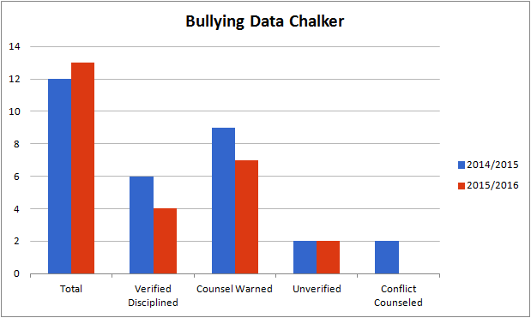

During the 2014/2015 School year there were about the same number of bullying reports as the previous year.

Of the 13 reports, 2 were unverified. There were 7 cases that were initial offenses and the students were counseled regarding the impact of their actions and warned. There were 4 cases that warranted discipline.

Counseling students is an ongoing part of the investigative process and all students involved were counseled regarding their behaviors.

