Bullying Data
Southington Elementary

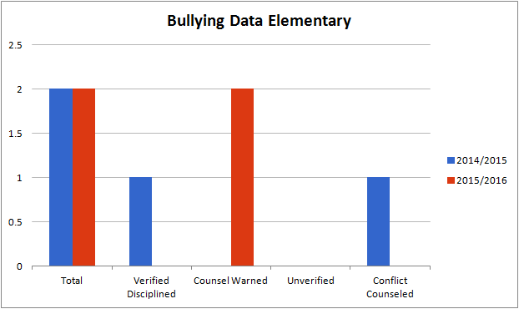

There were the same number of bullying reports during the 2015/2016 school year as the previous year but neither of the cases deemed discipline. All of the students involved in the incidents were counseled regarding the impact of their actions on others and warned of consequences for any further behaviors.

