Chalker High School
Bullying Report
2017-2018
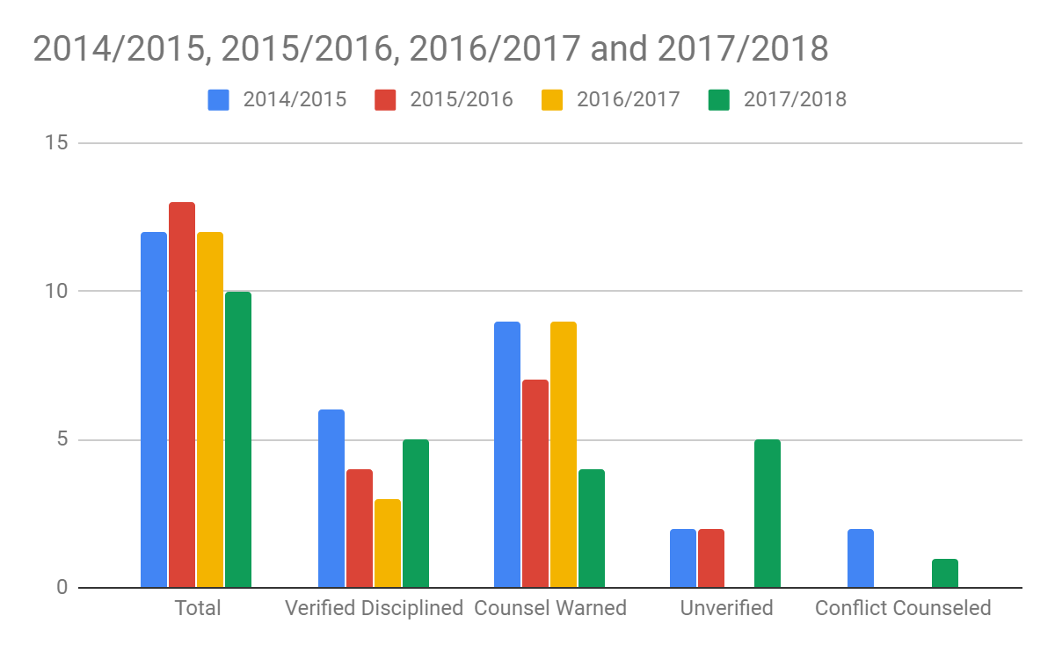
During the 2017/2018 School year there were 10 reports of bullying at Chalker High School. Three of those 10 reports involved the same student and only 1 of the 3 incidents was verified. Two of those 10 reports involved one other student and led to discipline twice. Of the total 10 reports, 5 were verified. All students involved in the 10 reports were counseled and

