Southington Middle School
Bullying Data
2017-2018

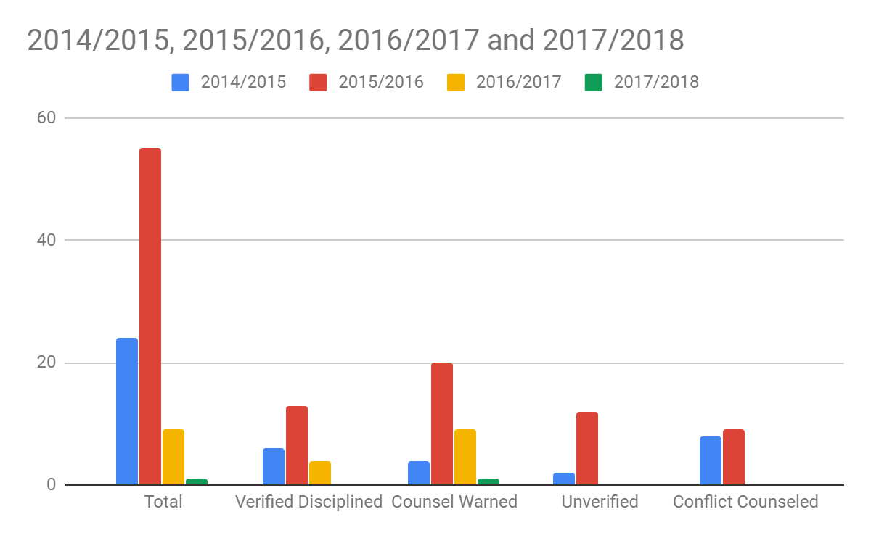

Middle School reports on Bullying were down in the school year 2017-2018. All students involved in the incident were counsel and warned.

