Southington Middle School
Bullying Data

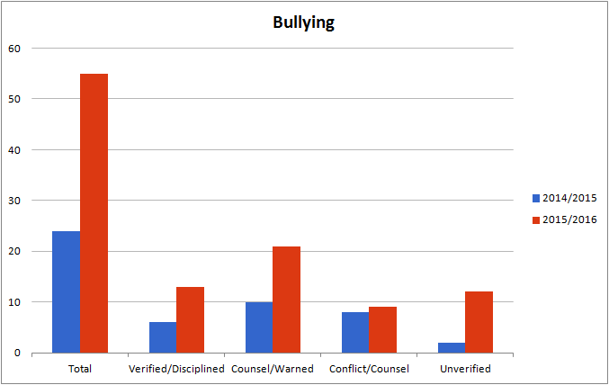

There was an increase in bullying complaints during the 2015/2016 school year most likely due to 2 reasons. First off the fact that the middle school students seemed more comfortable in reporting bullying and secondly because of the 55 bullying complaints 21 of them involved the same repeated offenders. 13 of the 55 complaints involved a group of 3 students and another 8 involved 2 separate students.

Of the 55 reports during the 2015/2016 school year, 12 were unverified and 9 were found to be conflicts among peers. 21 of the reports were actually not repeated offenses and therefore not cases that were actually deemed bullying but did require attention. The students involved in these cases were all counseled and warned.

13 of the reports were deemed bullying and warranted disciplinary action.

Counseling students is an ongoing part of the investigative process and all students involved were counseled regarding the impact of their actions.

